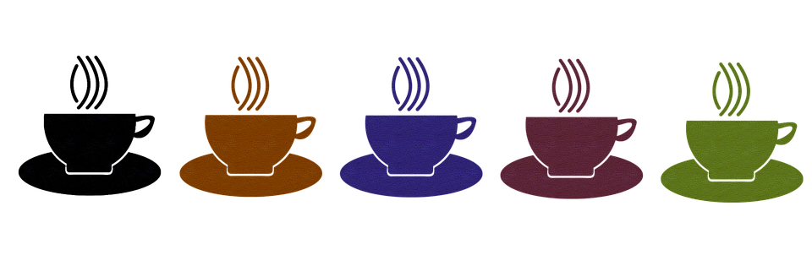

MENU

**Special deal**

Because I could not stop for death. He kindly stopped for me

the carriage held nothing but ourselves. And immortality. We

we Slowly drove he knew no haste. And I had put away

**Home Town**

One Two three four five six seven eight nine

Ten eleven twelve thirteen fourteen fifteen

Sixteen seventeen.