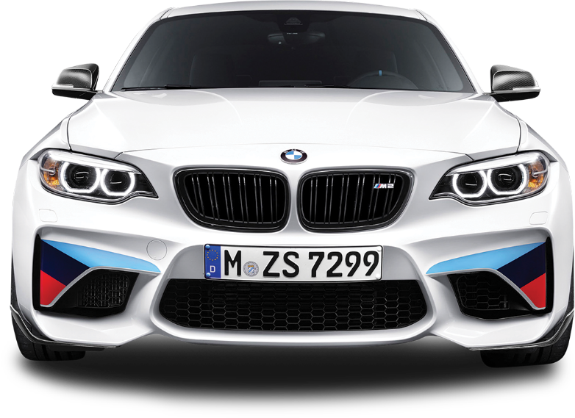

www.flyerstemplates.com

**Car**

**Wash**

**service**

Shining Body

**Mr. Mike**

Contact Person:

$99

From

Only

**1 (123) 456 7890**

**Get a Special Discount on Your First Car Service**

Civic Center, 32st Street, Stetler, Alberta